# **Homework 5**

**Sandhya Mamidi(S02061097)**

**Recipe App**

**Recipe App Home Page:**

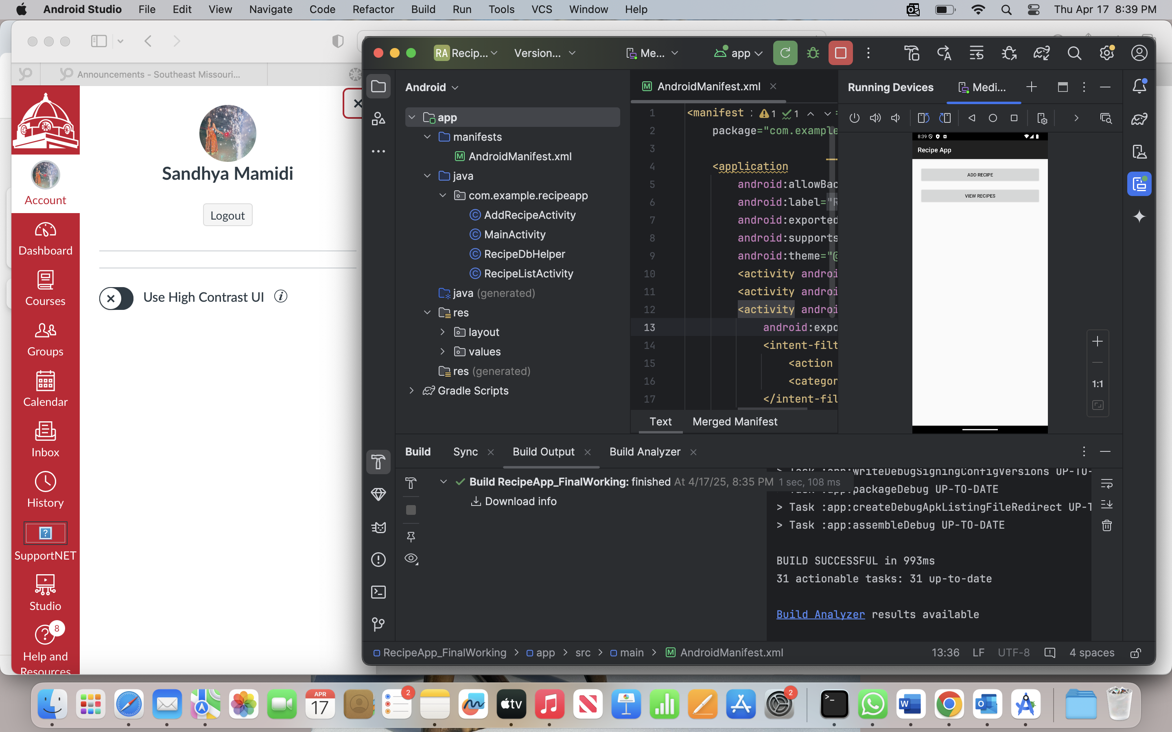

**Detailing to Add a Recipe :**

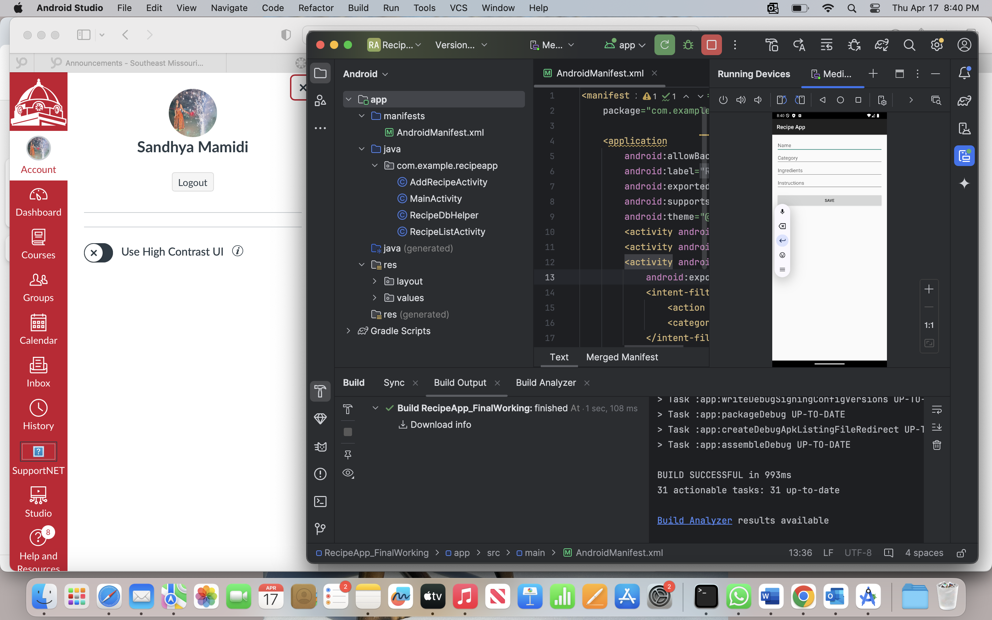

**Description of my Recipe:**

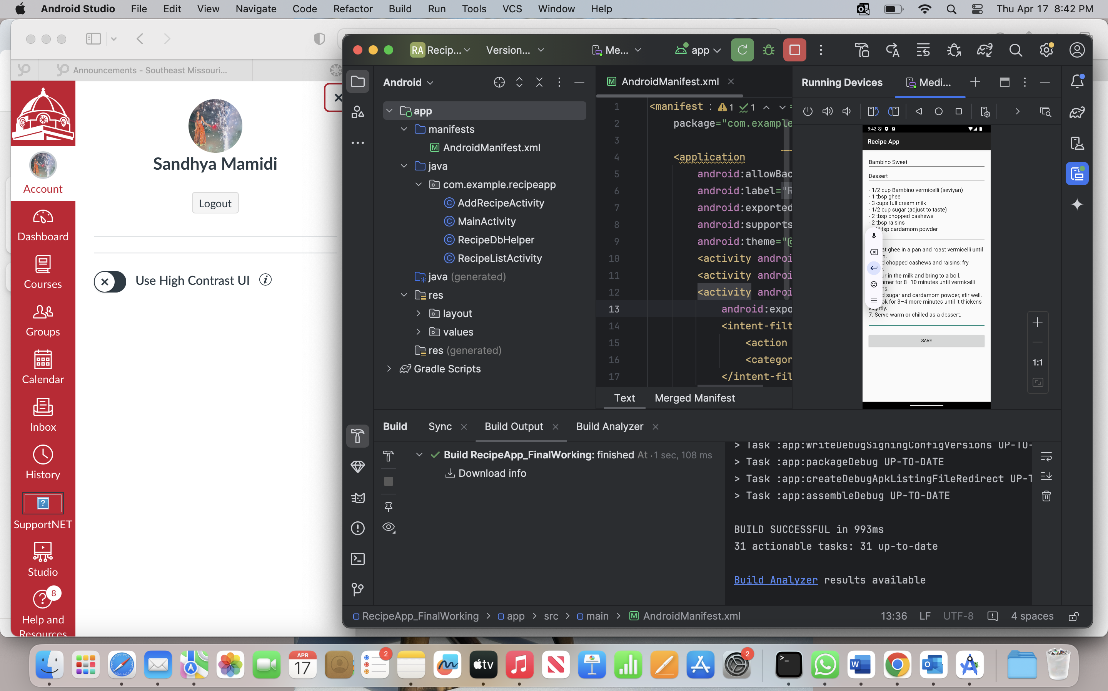

**Recipe Added and viewed in the ViewRecipe:**

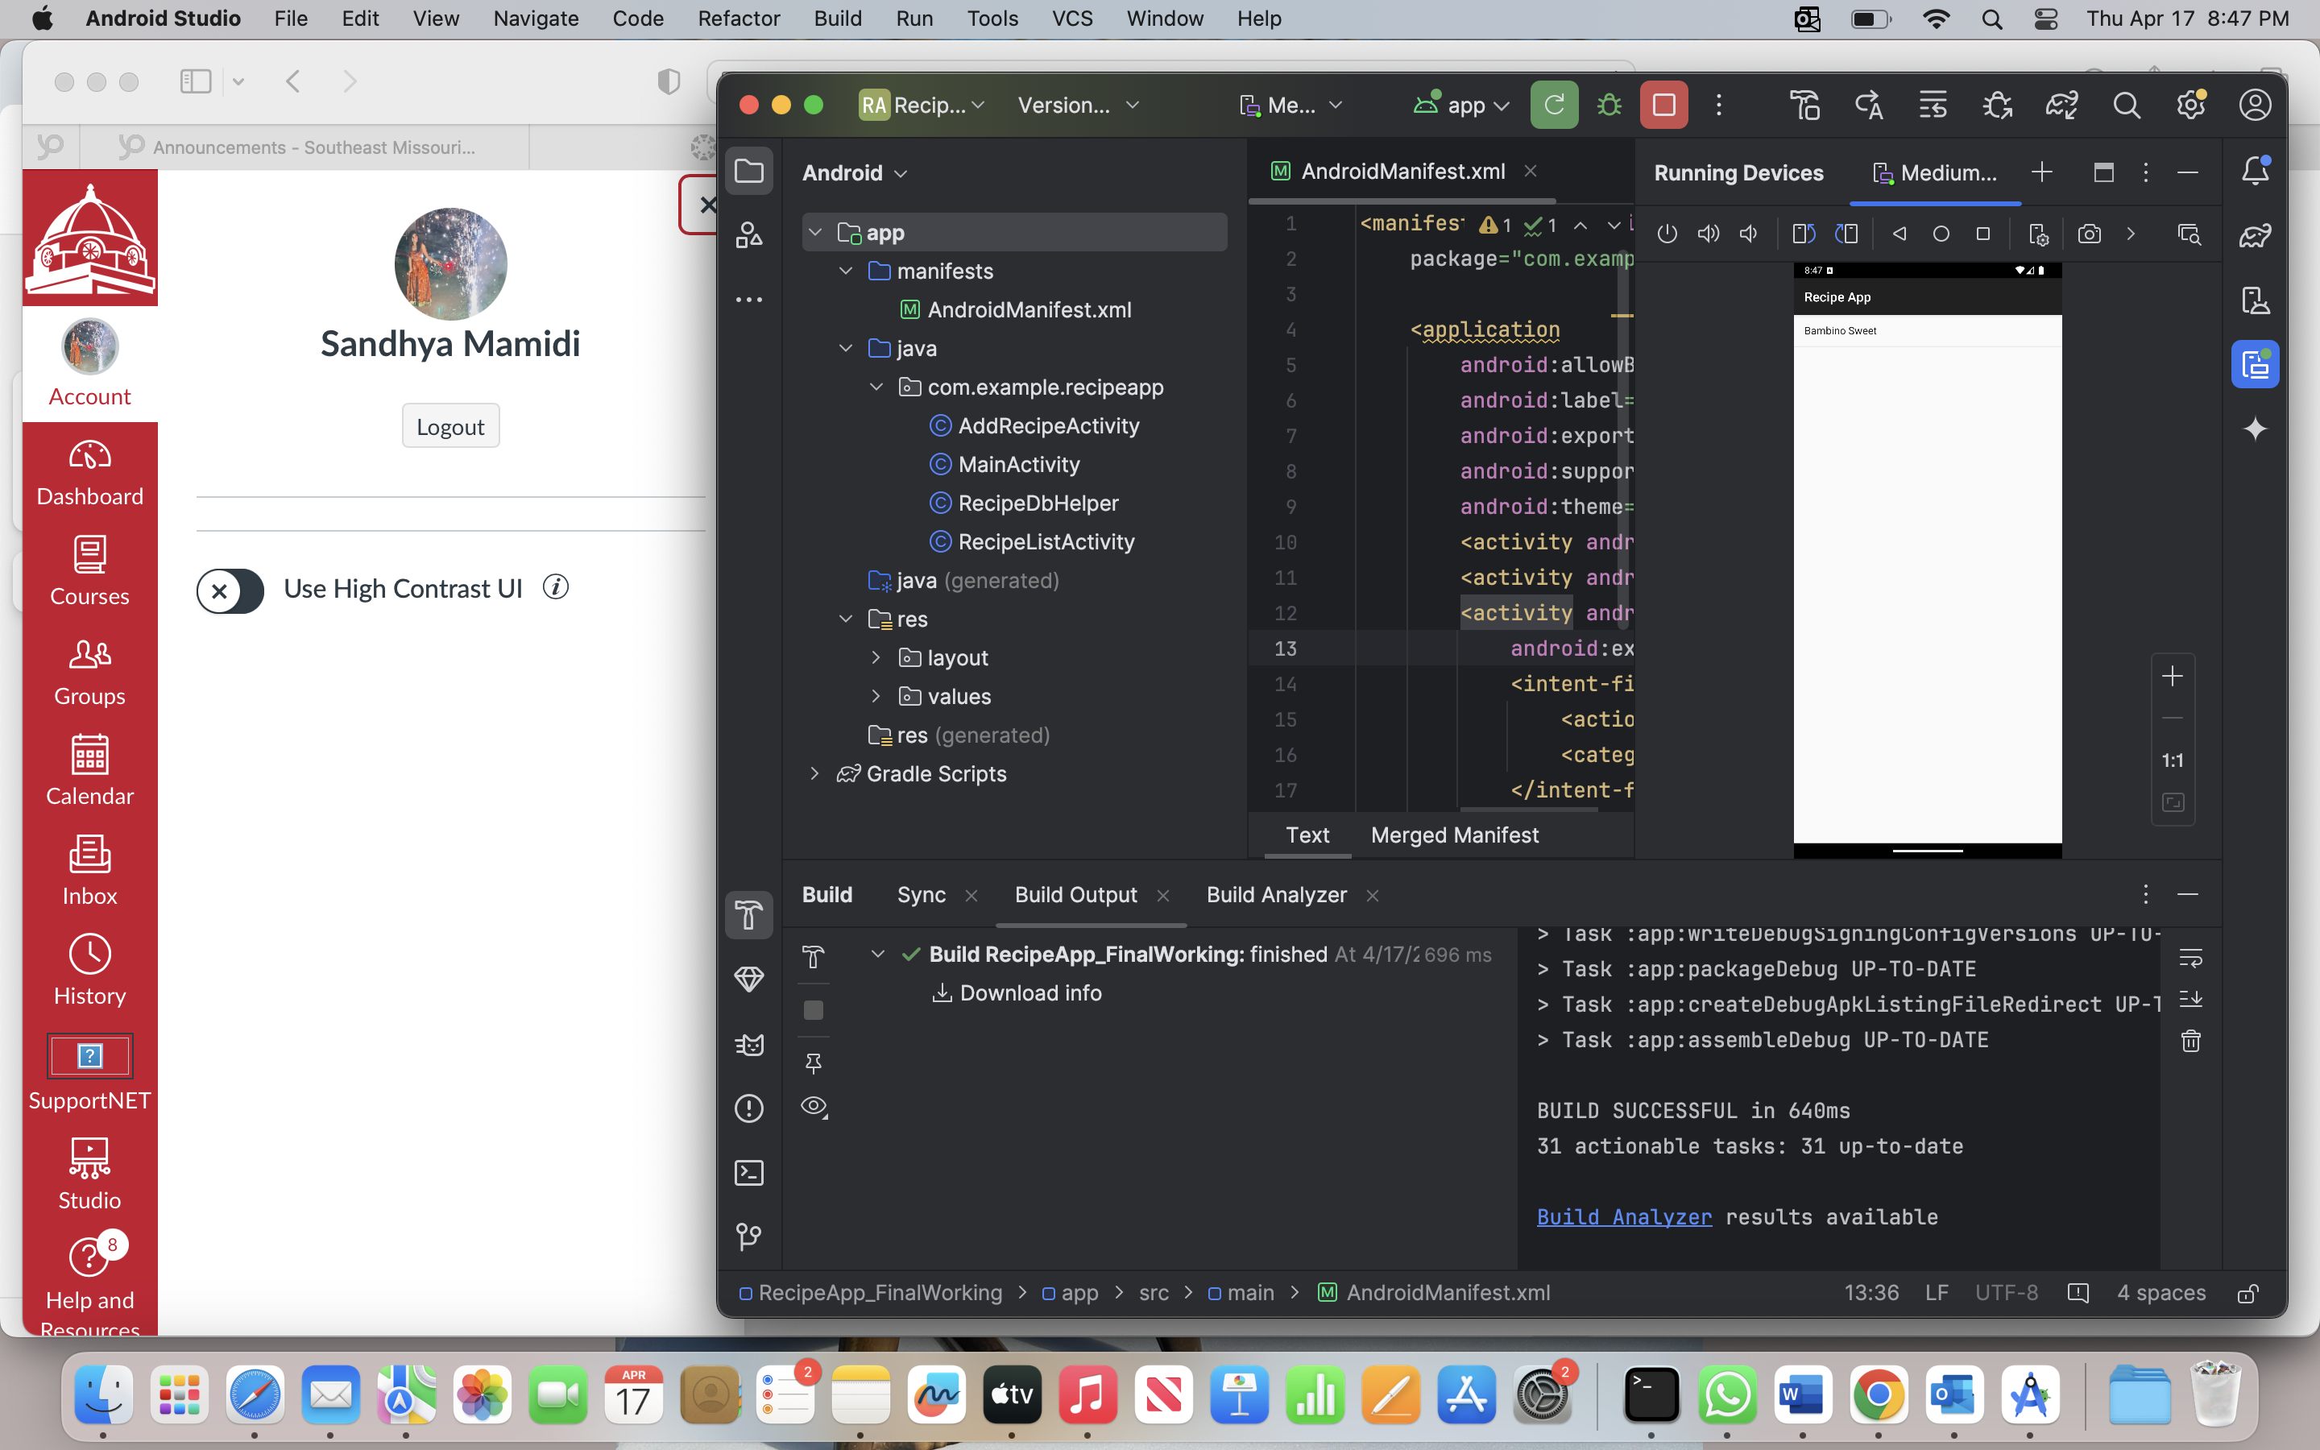

**By clicking on it we can view the details of Recipe and also we can update if we want change the taste of Recipe:**

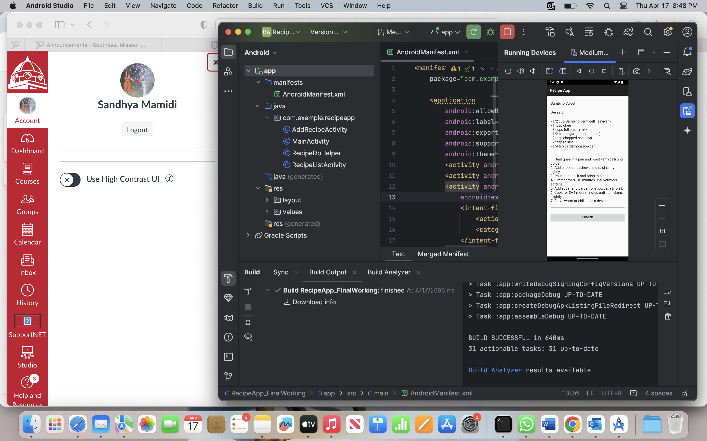

**Added more Recipes and in alphabetical order:**

